**Step 1:** Open Azure DevOps site

[https://dev.azure.com](https://dev.azure.com/)

**Step 2:** Create New Azure DevOps project

Project Name: **DevOps-ProjectDemo**

Visibility: **Private**

Click on **+ Create project**.

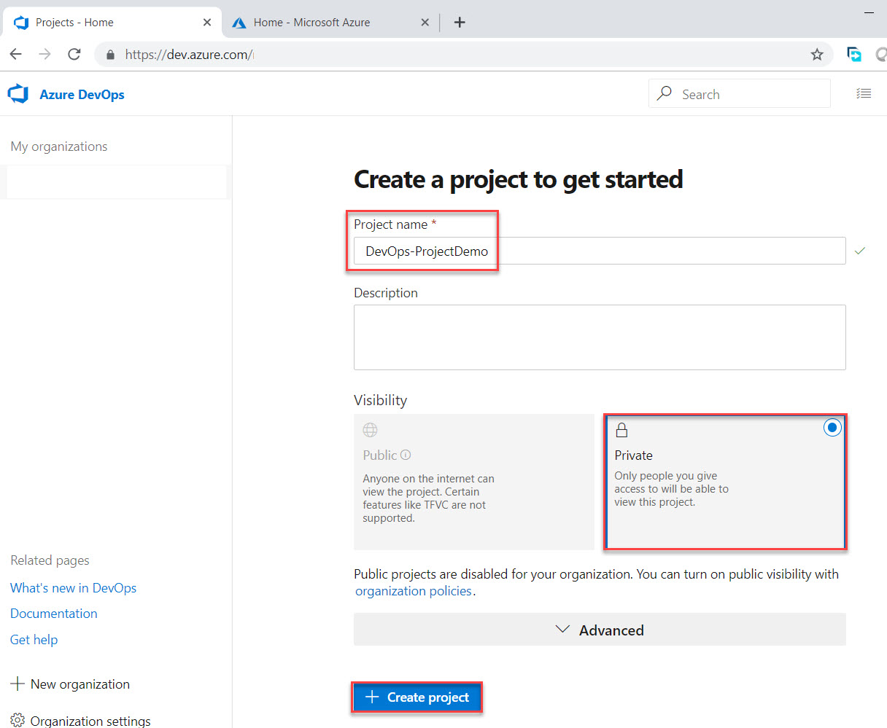

**Step 3:** First Select **Repos**. Right side you can see multiple options for adding code

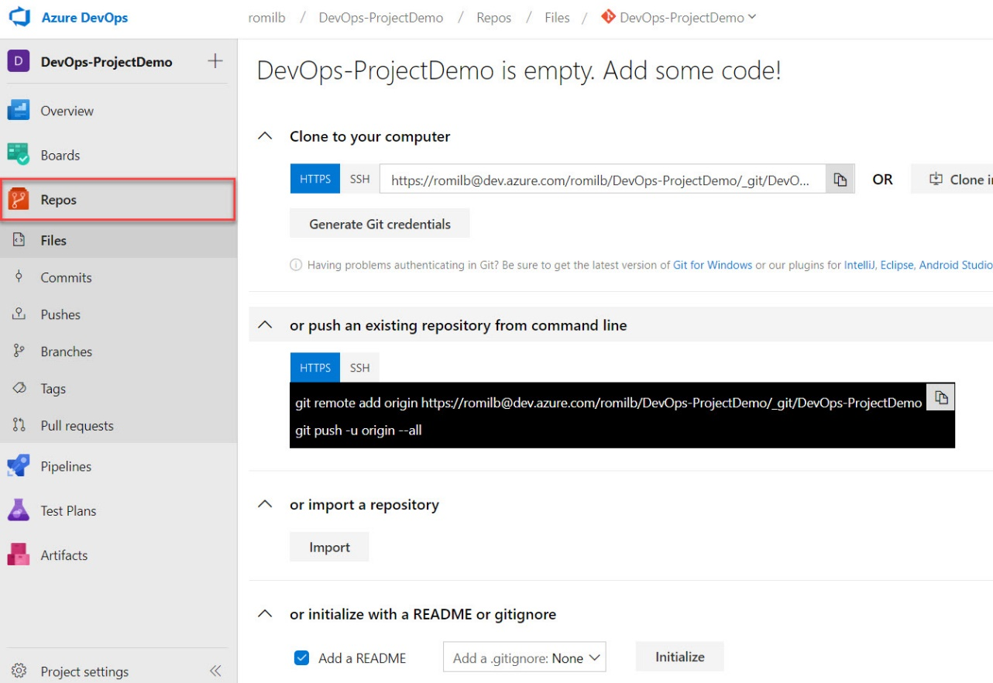

**Step 4:** Start **Visual Studio**. Select **Team Explorer** and click on **Connect** of Azure DevOps.

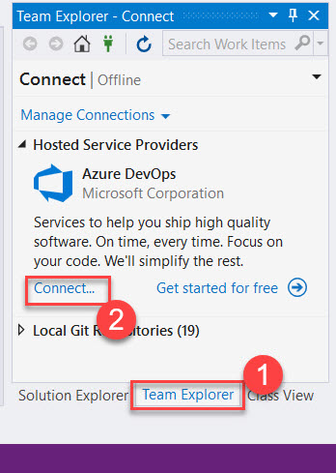

**Step 5:** Login with Azure DevOps Credentials. Select **existing DevOps Project** recently you have created.

Click on **Clone** button.

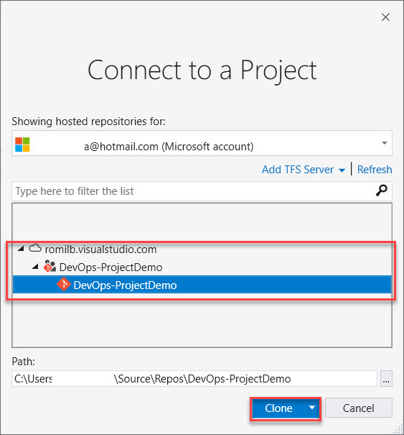

**Step 6:** Right Click on Folder and Click on **Copy Path** option

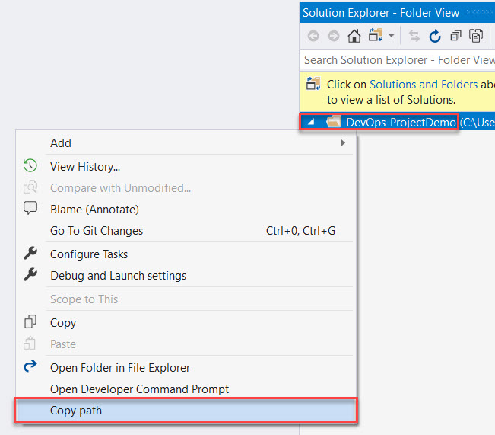

**Step 7:** Create Web Project

**Visual C# -> Web -> ASP.NET Core Web Application**

Change Location of Project. **Paste** path here.

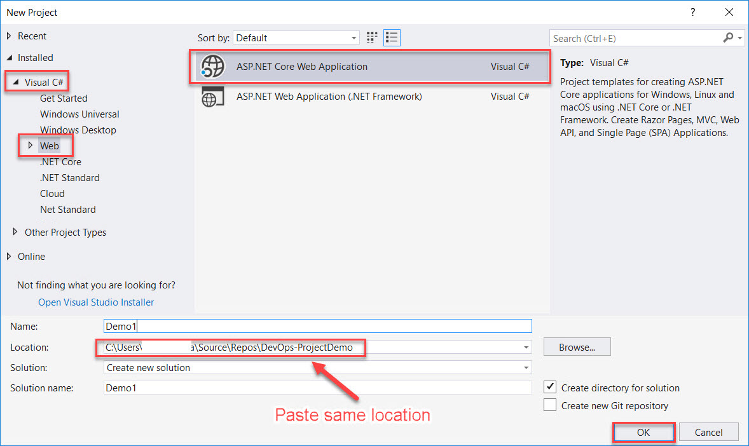

Choose **Web Application (Model-View-Controller)** and click on **OK** button.

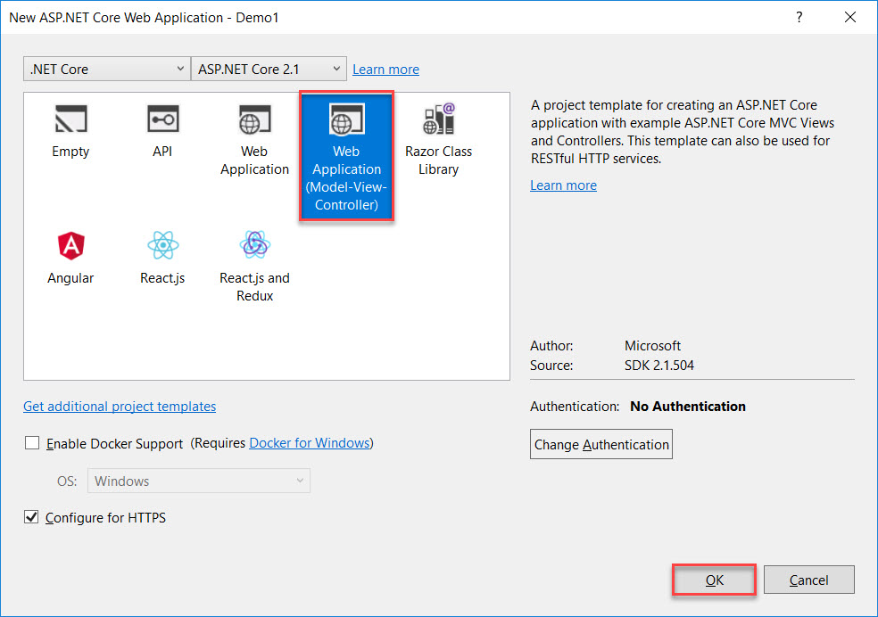

**Step 8:** Sample Web Project will look like as below:

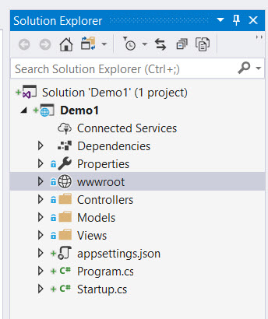

**Step 9:** Click on **IIS Express**

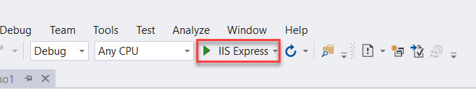

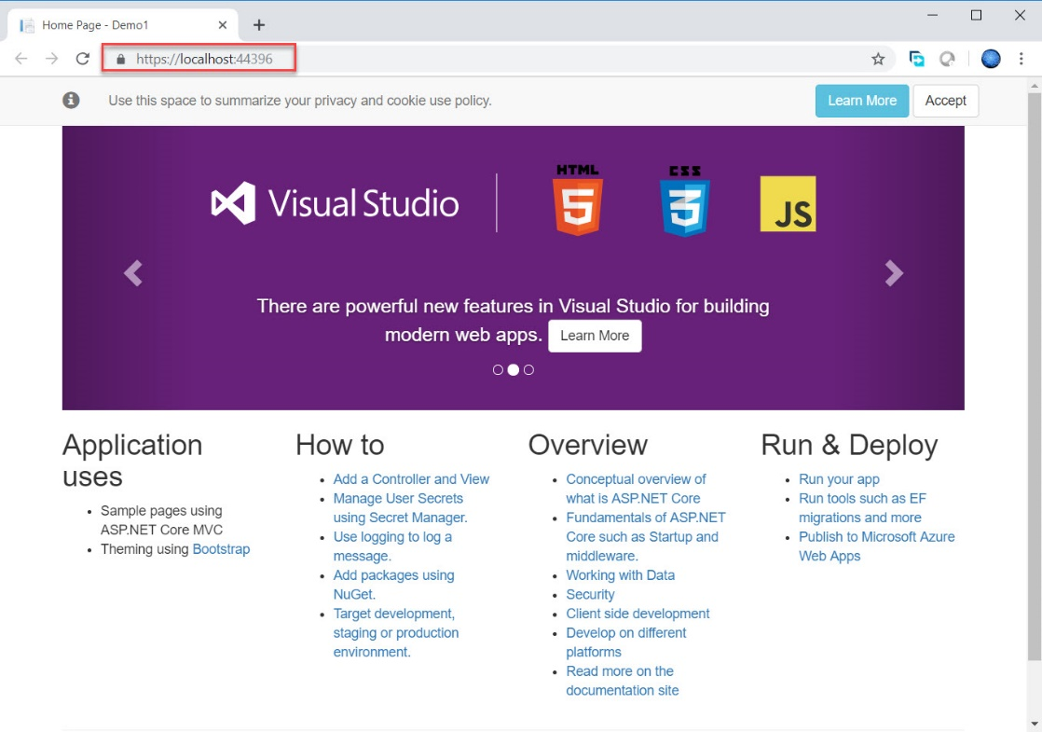

**Step 10:** Navigate to Visual Studio and click on **Settings** in Team Explorer

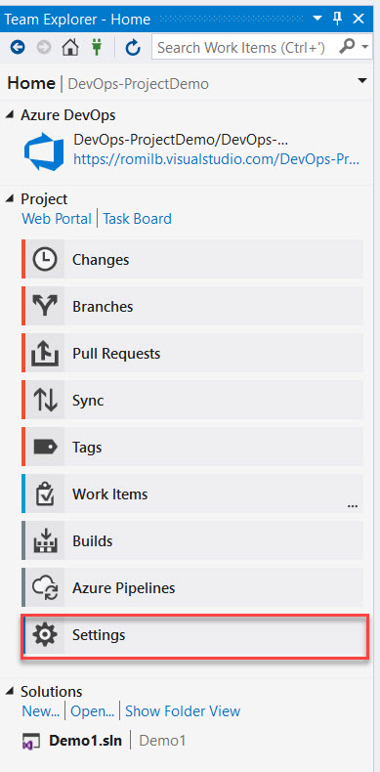

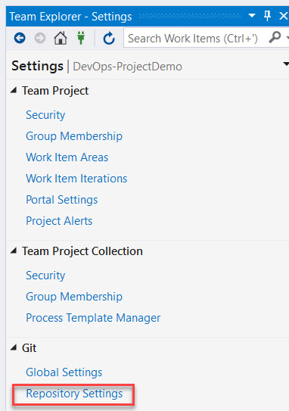

Click on **Repository Settings**

Click on **Add** button under **Ignore file**

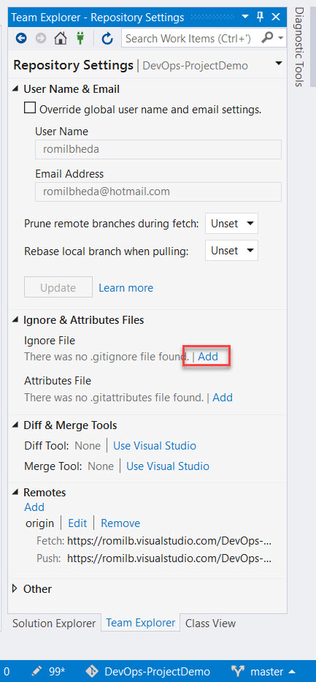

Click on **Home** button and select **Changes**

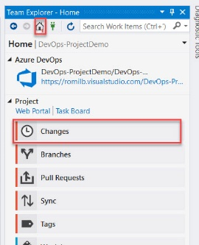

Type message and click on **Commit**

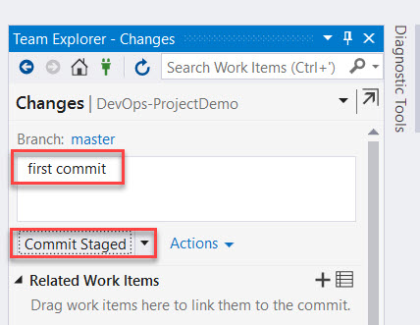

Click on **Sync** option to reflect on server.

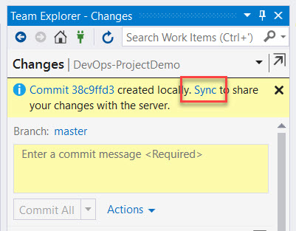

Wait for few seconds to push the code.

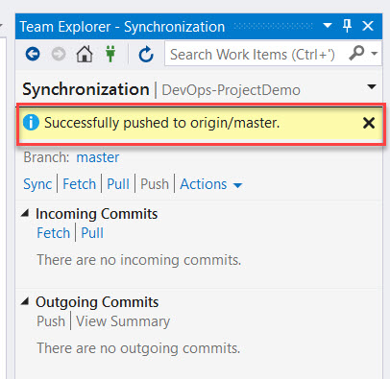

When all item pushed icon also update to lock icon.

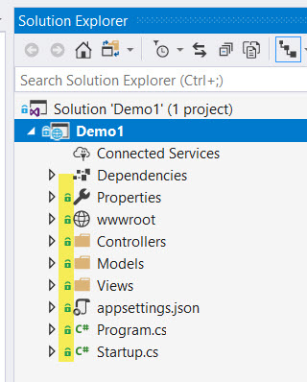

To check all code pushed, navigate to Azure DevOps and Refresh Repos. Folder will be there as below:

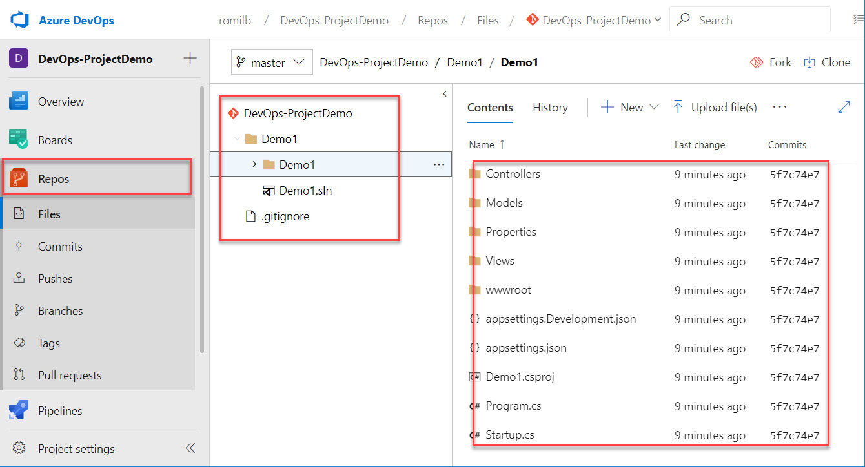

**Step 11:** Open Microsoft Azure Portal in another tab

[http://portal.azure.com](http://portal.azure.com/)

**Create Web App**

**Click on + Create a resource -> Web -> Web App**

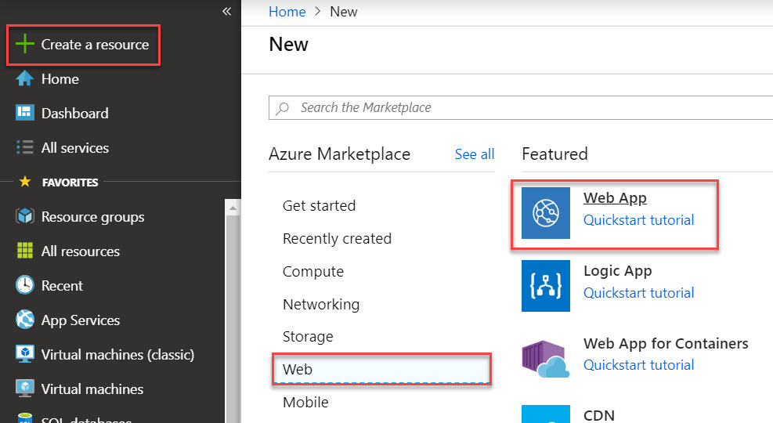

**Step 12:** Create Web App

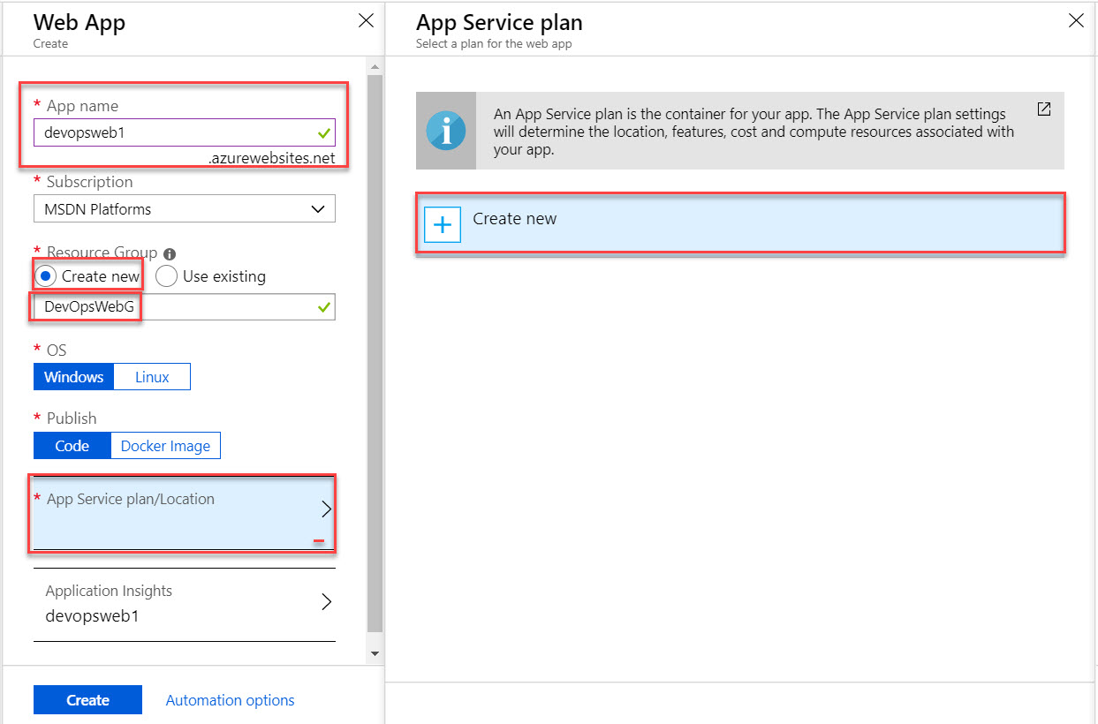

Create New App Service Plan

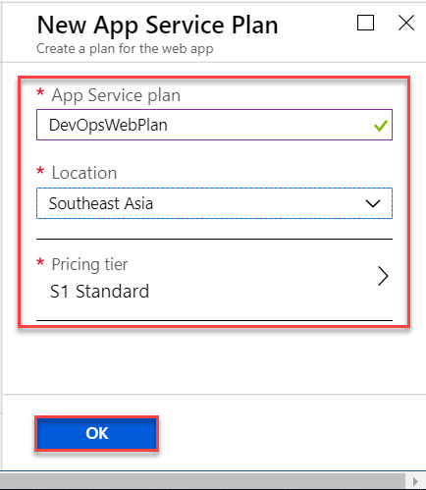

**Disable** Application Insights.

Click on Create button.

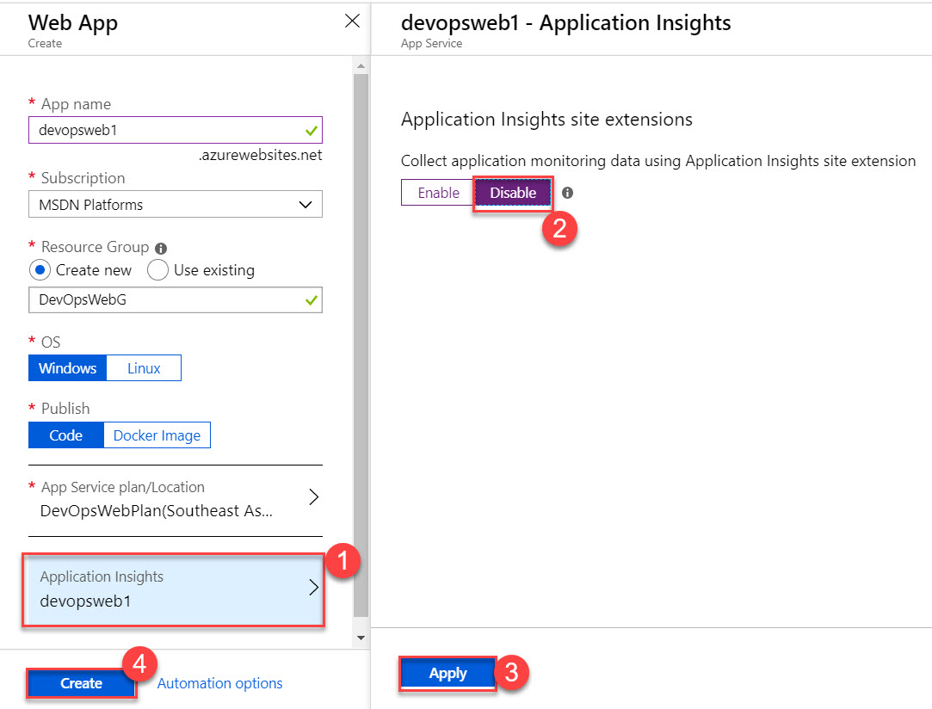

**Step 13:** One again Navigate to Azure DevOps.

Create **New Pipeline** under **Pipelines** option

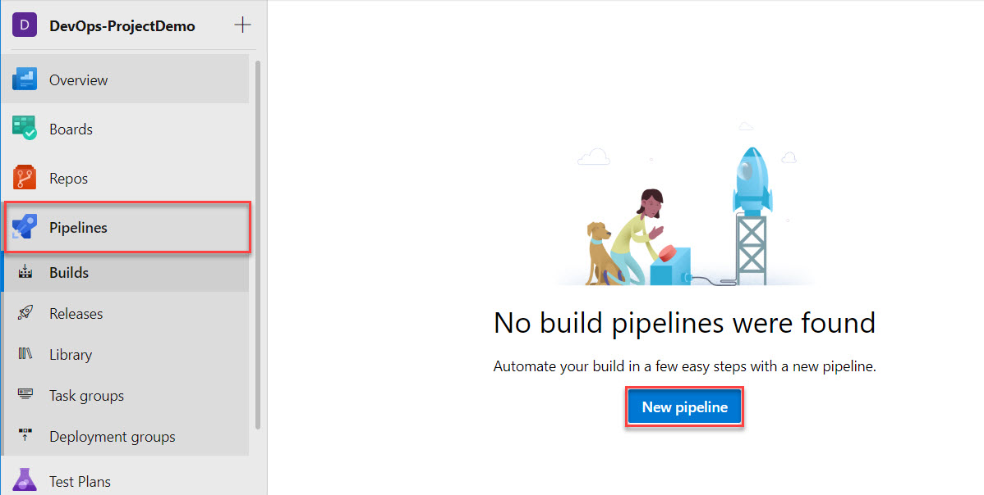

Select **Azure Repos Git** as a Source and Click on **Continue** button.

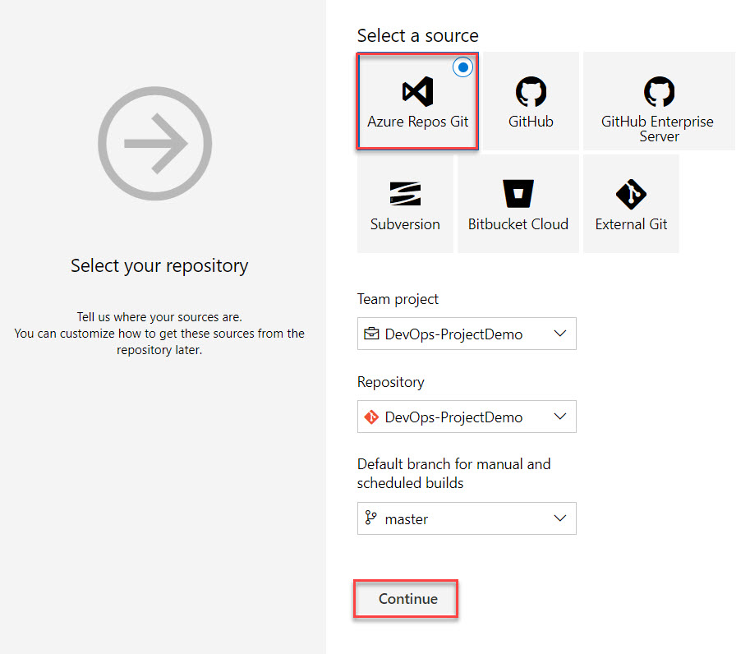

**Step 14:** Search for **ASP.NET** and Click on **Apply** option

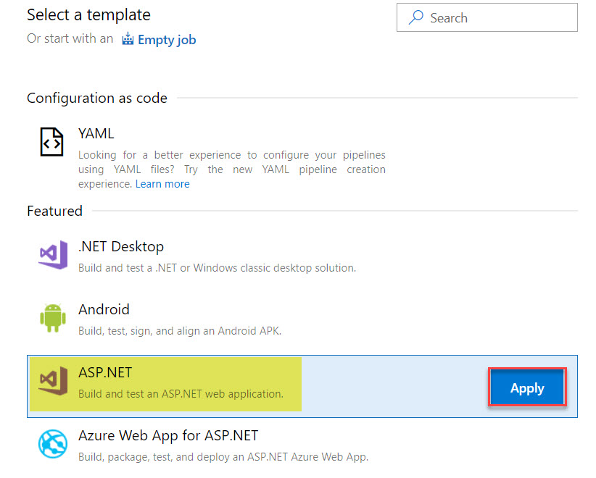

**Step 15:** Click on **Save & queue** button.

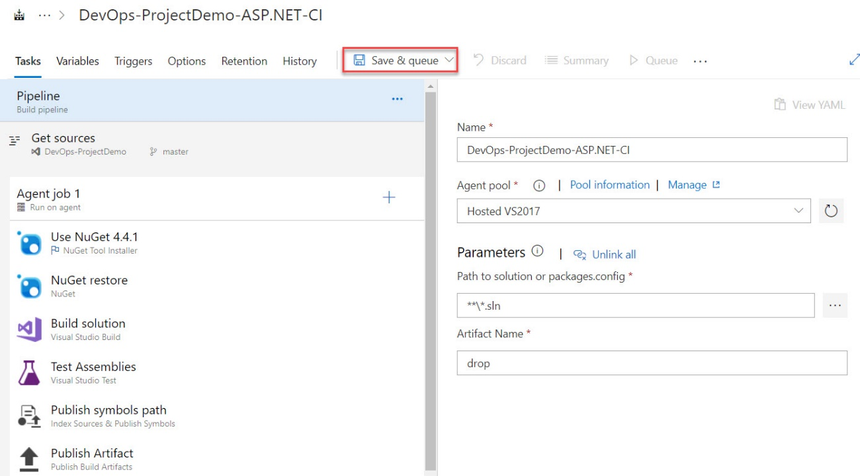

Click on **Save & queue** button.

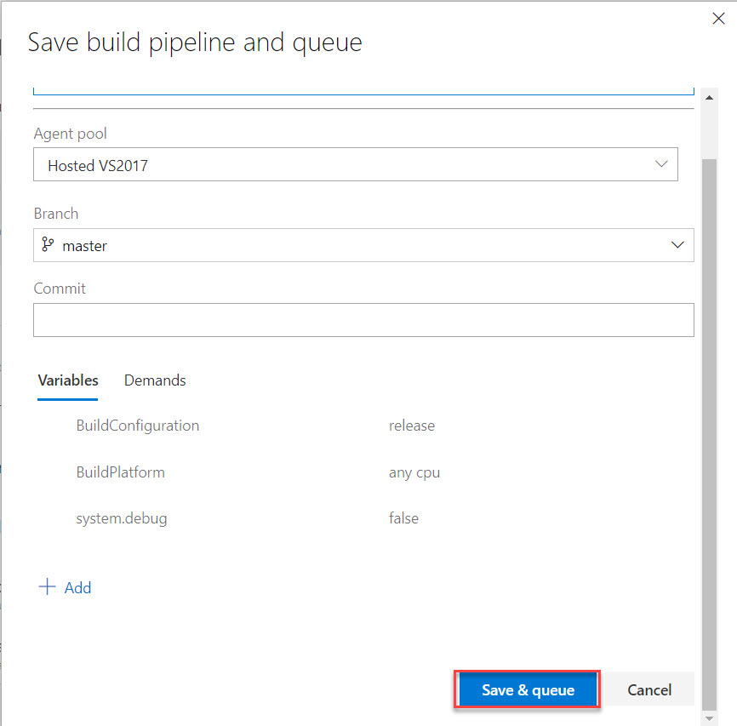

**Step 16:** Click on **Build**

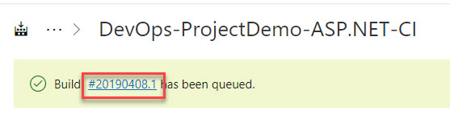

Agent Job will start. Wait for few minutes to complete all Jobs.

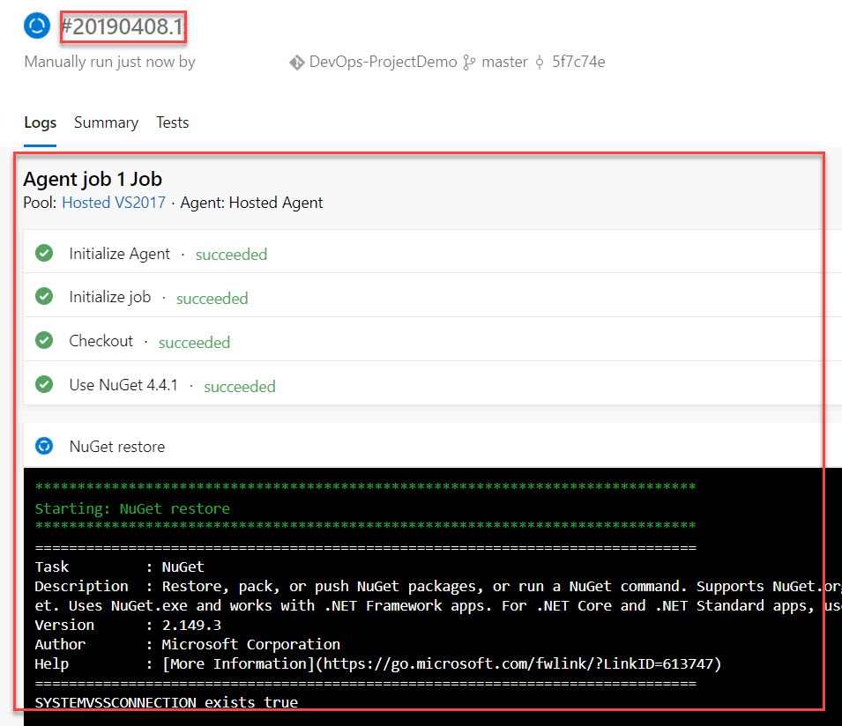

All Agent Job Succeeded.

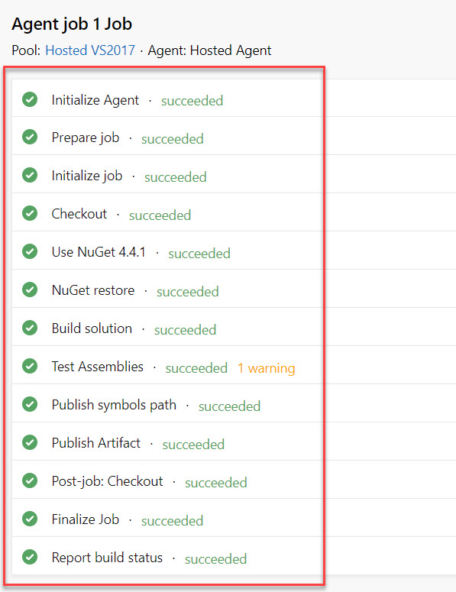

Also you will receive Mail

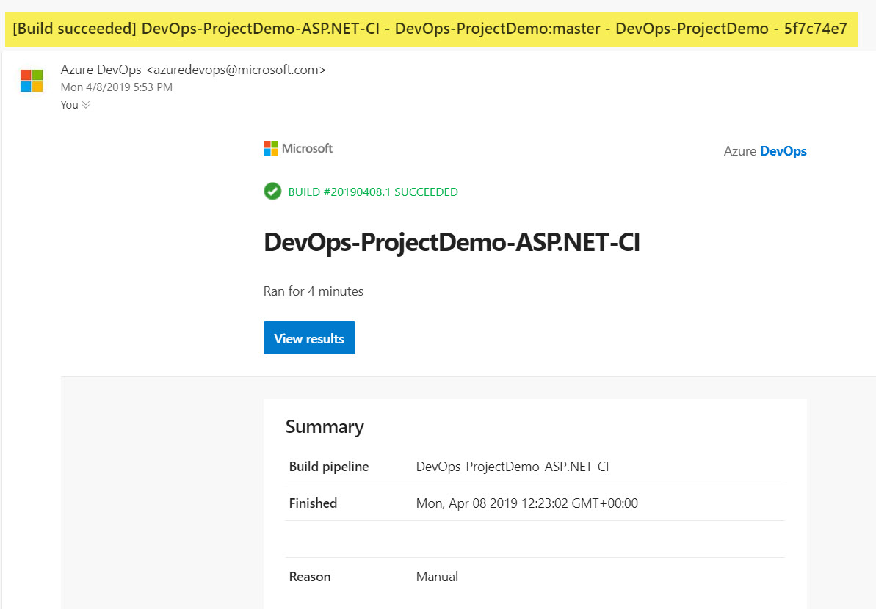

**Step 17:** Create **New Release Pipeline**

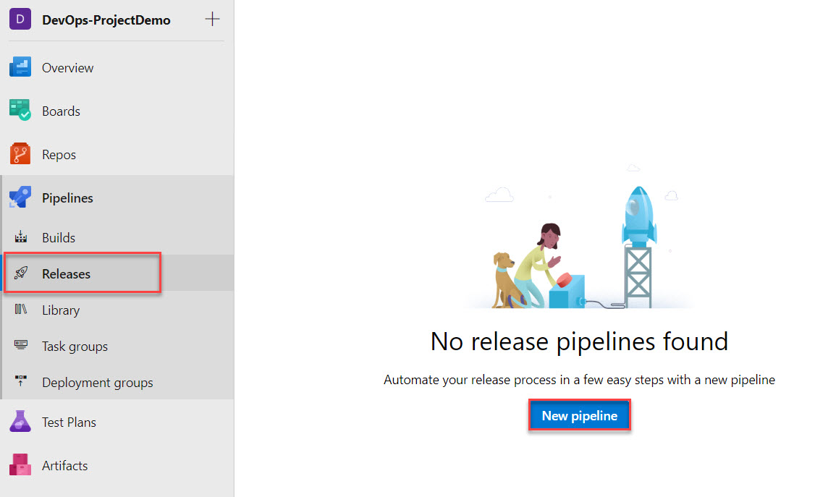

**Step 18:** Select “**Azure App Service deployment**” and Click on **Apply** button.

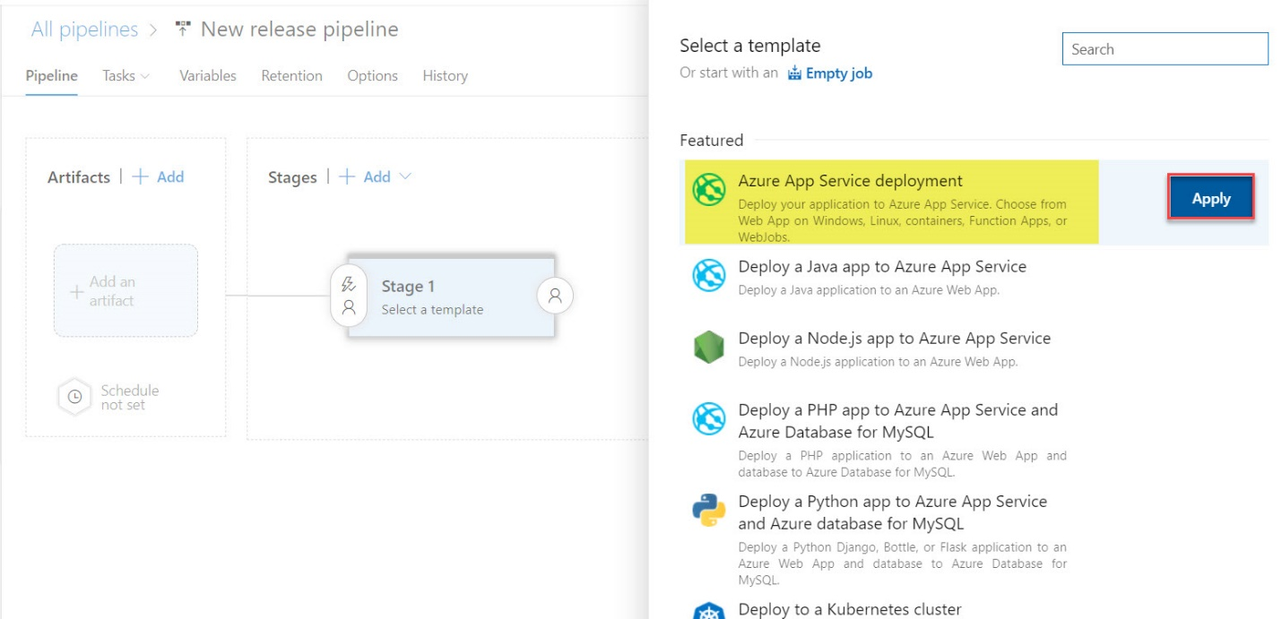

**Step 19:** Click on **Add an artifact** option

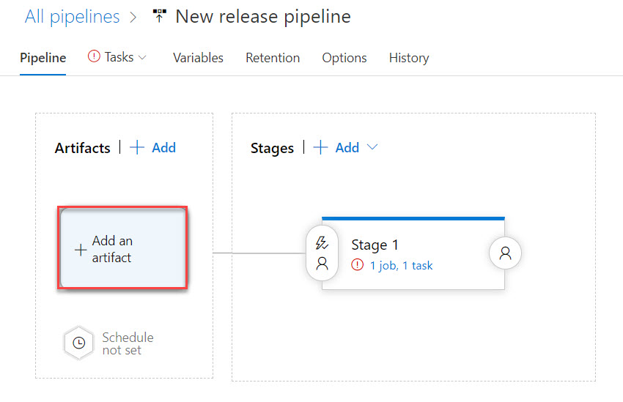

**Step 20:** First Select Source type as **Build**.

**Select Project, Source, Default Version and Source alias.**

Click on **Add** button.

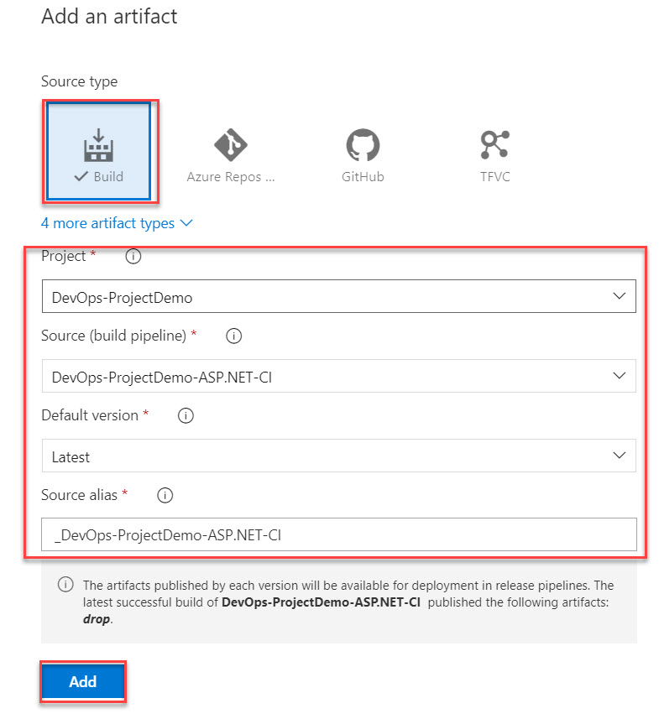

**Step 21:** Select **Tasks** tab

Select **Azure Subscription** and click on **Authorize** button.

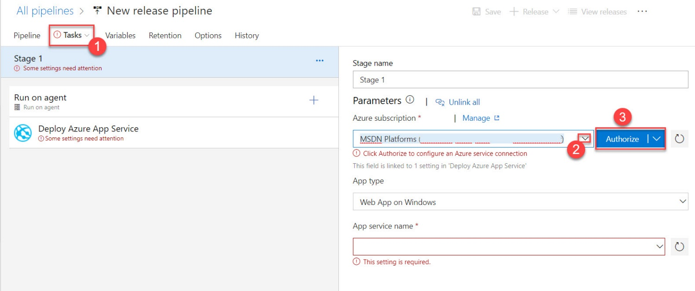

Enter Email Id and Password

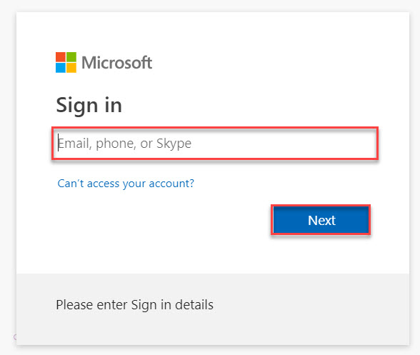

App type: **Web App on Windows**

App Service name: **Choose from drop menu**

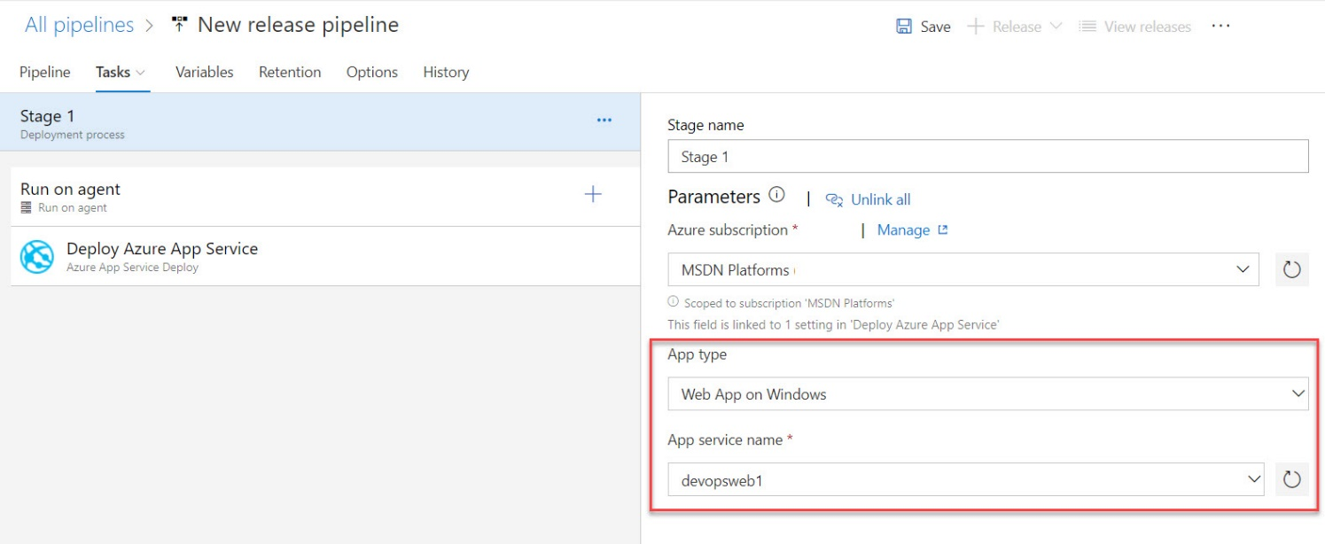

**Step 22:** Select **Deploy Azure App Service**

Click on **…** of **Package or folder** option

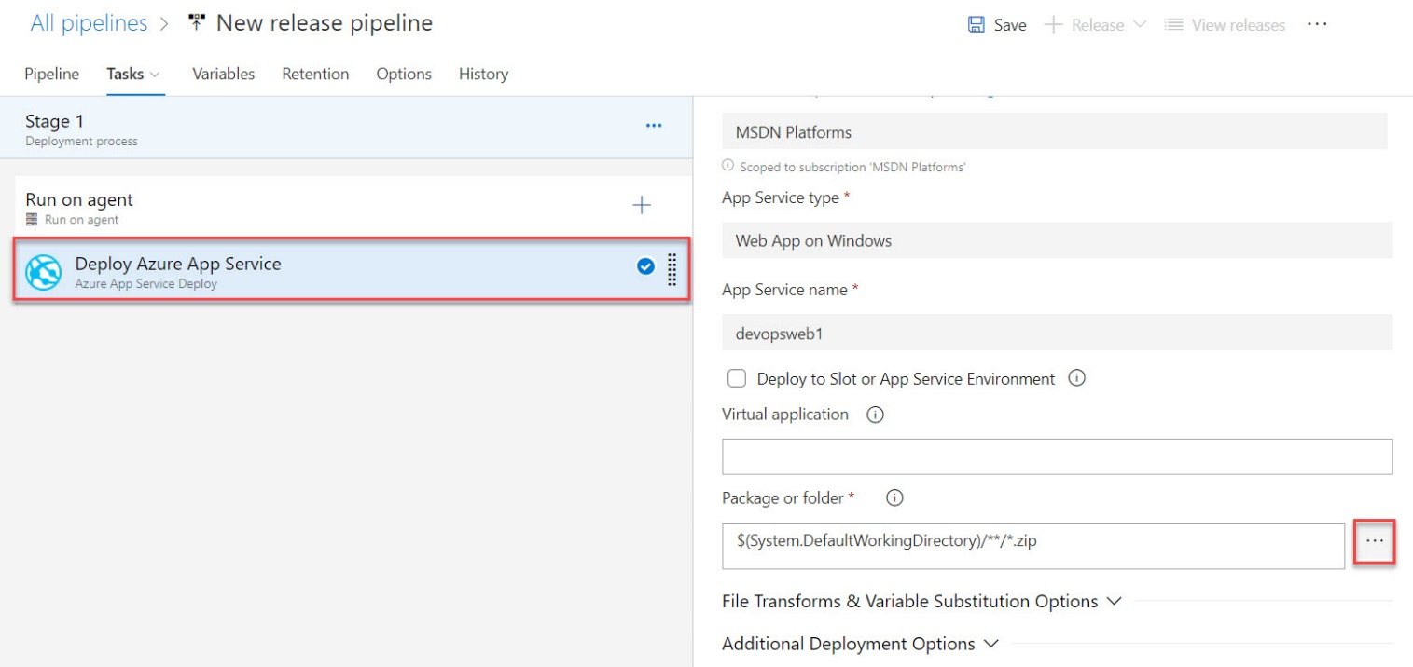

Expand Build and select **.zip file** Ex. ProjectName.zip

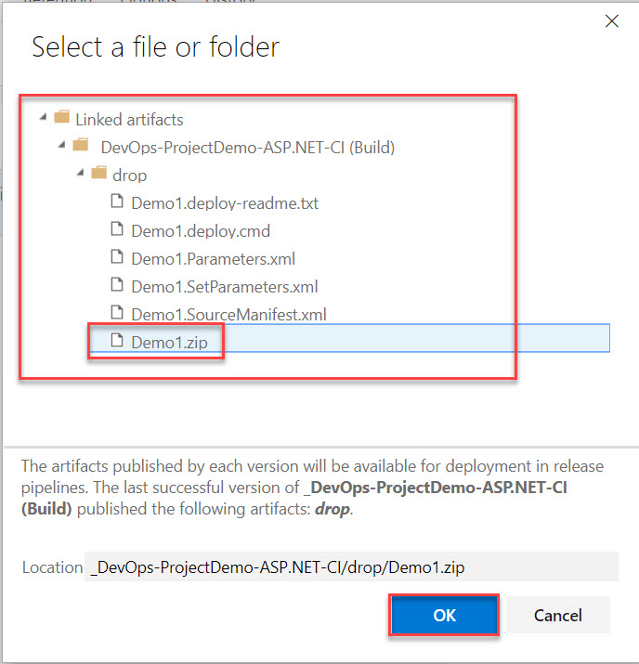

**Step 23:** Click on **Save** button.



Click on OK button.

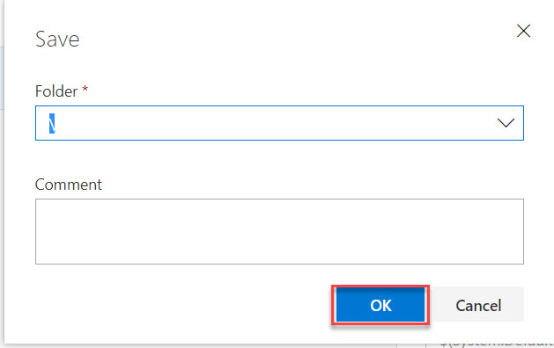

**Step 24:** Click on **Create Release**

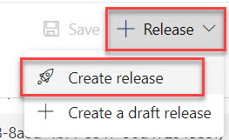

Go with default option and click on Create button.

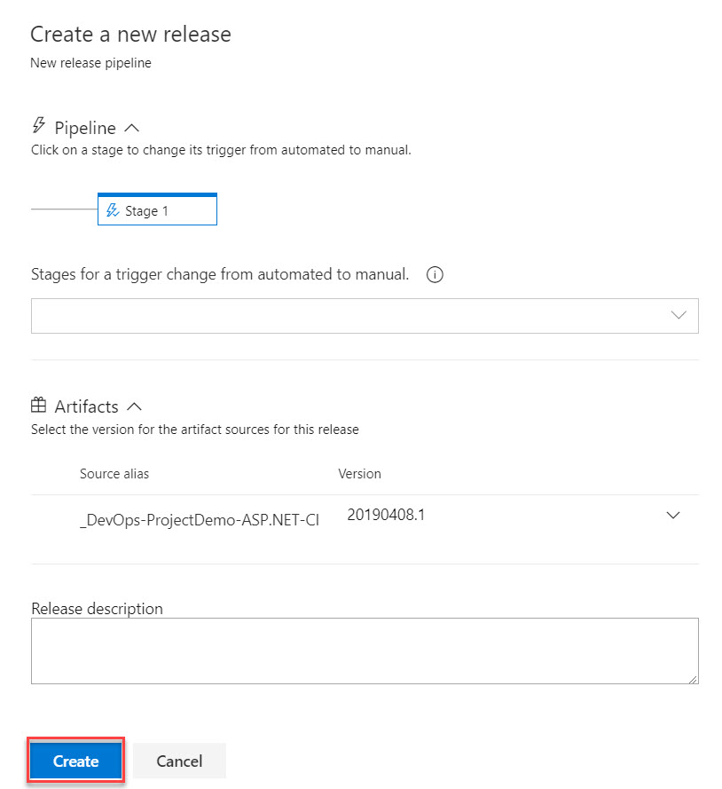

**Step 25:** Click on **Release-1**



**Step 26:** All Tasks will start in stages

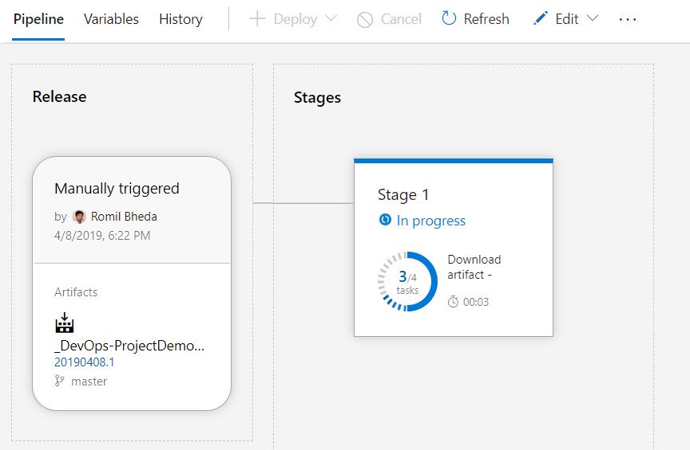

Within few seconds it will complete

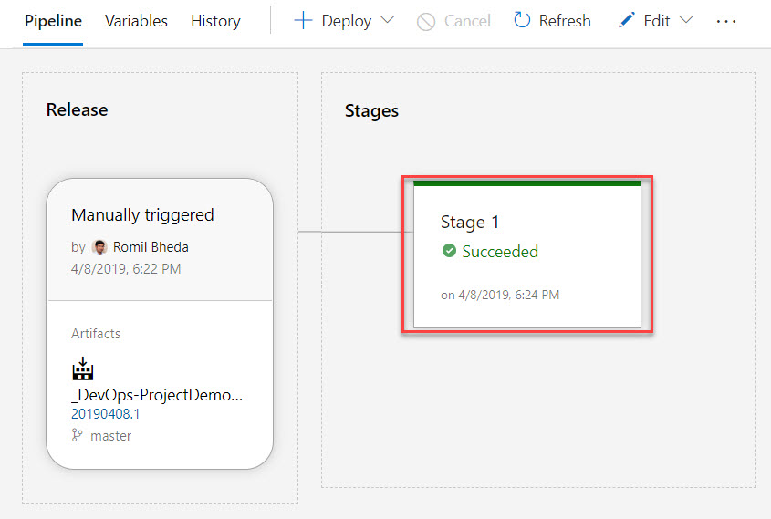

**Step 27:** Navigate to **Azure Web App** and click on **Browse** option

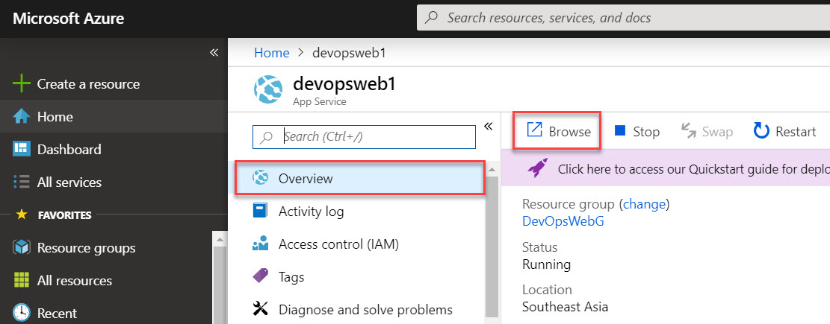

Web will execute with pushed code from Visual studio

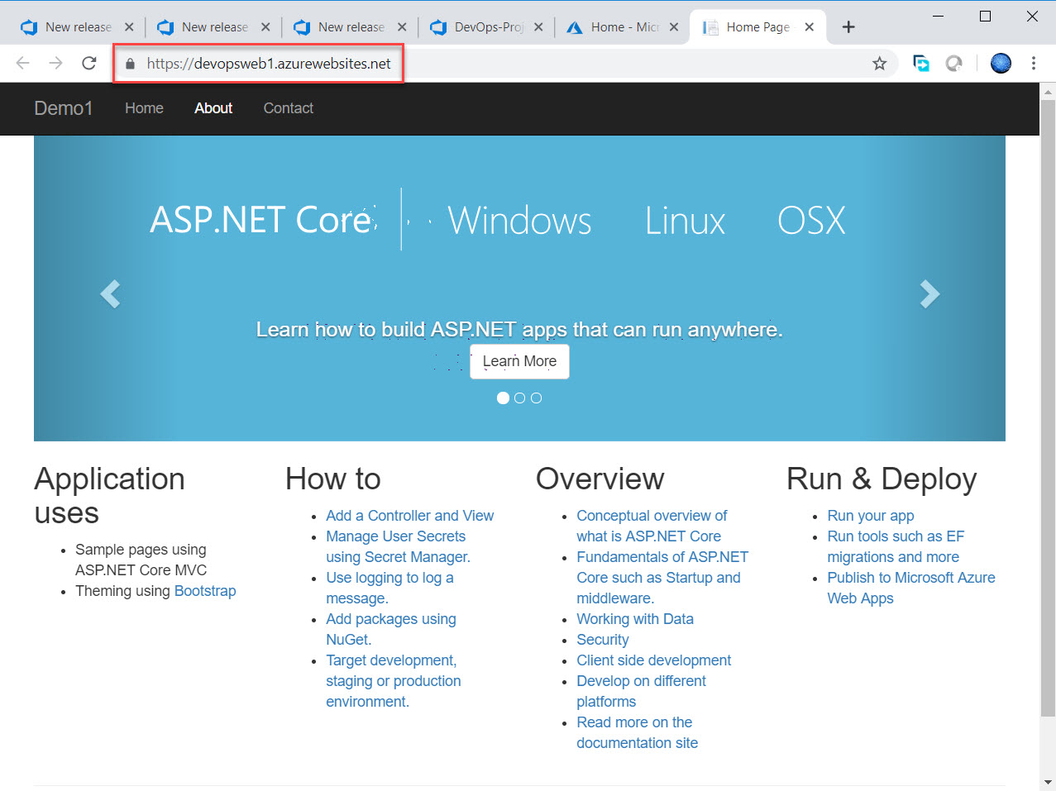

**For Continuous Integration (CI)**

**Step 28:** Select **Builds** and click on **Edit** option

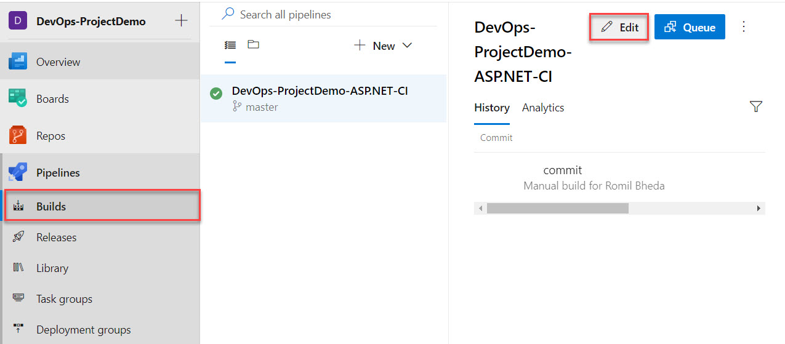

Select **Triggers** tab

Check mark on **Enable Continuous Integration**

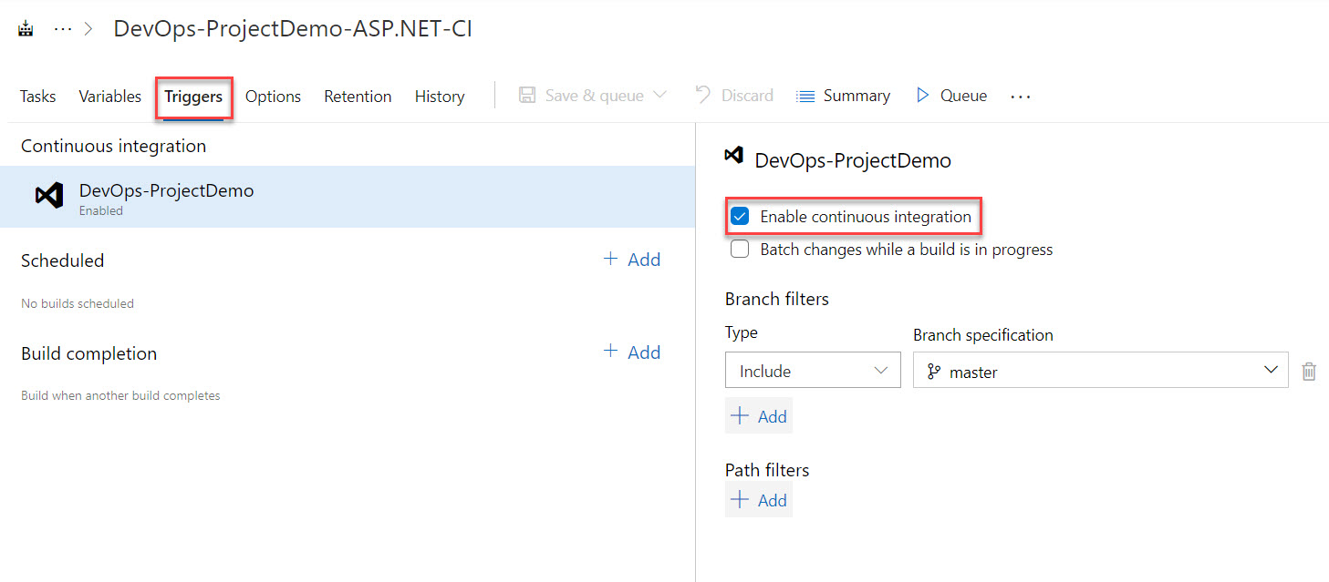

Click on **Save & queue**

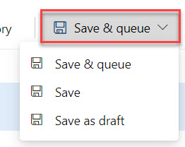

**For Continuous Deployment**

**Step 29:** Select **Releases** and Click on **Edit** option

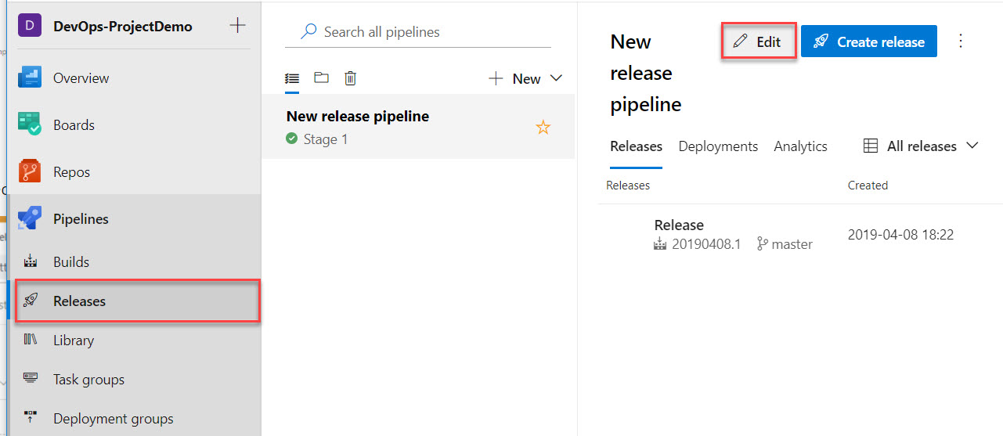

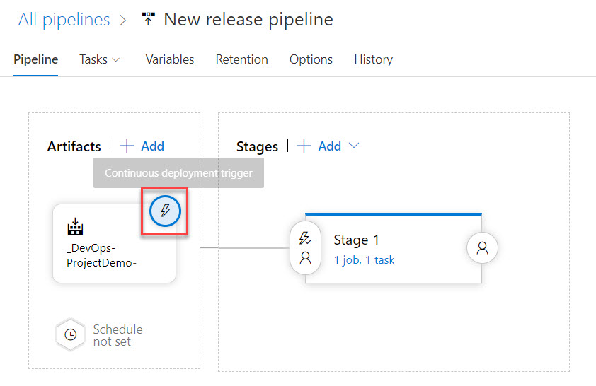

Enabled it and click on **Save** button.

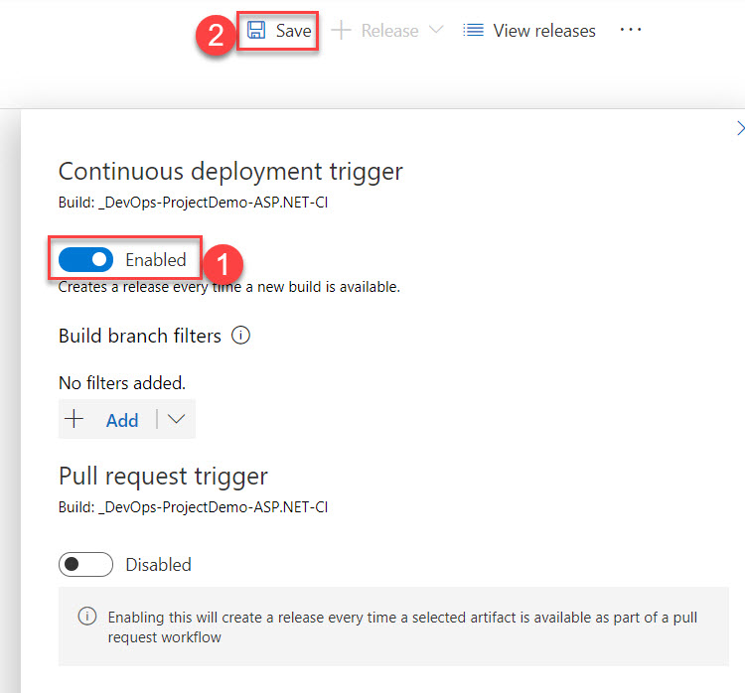

Type comment and click on OK button.

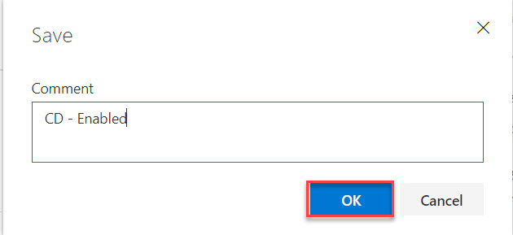

**Step 30:** Navigate to Visual Studio Projects

**Expand Views -> Home -> Open Index.cshtml**

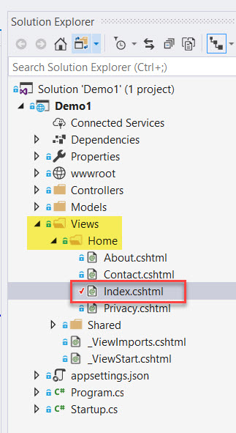

**Step 31:** Scroll Down and Add one line in Application uses

<li>For Azure DevOps Demo</li>

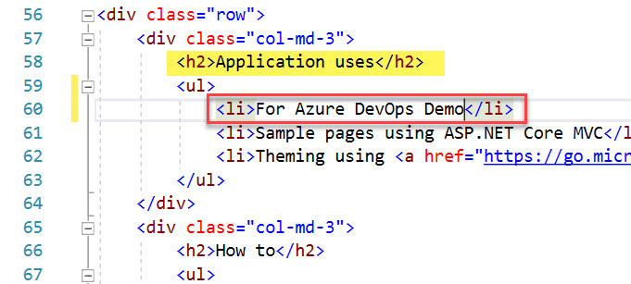

**Step 32:** Right click on **Index.cshtml** and Select **Commit**…. option

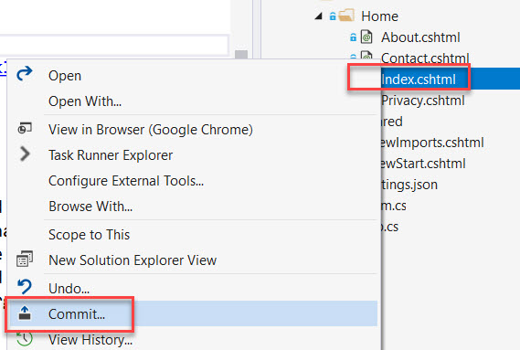

Type message and click on Commit All

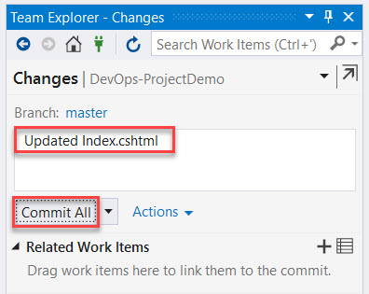

Click on **Sync** option

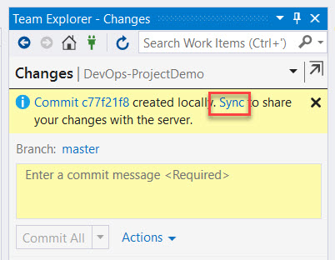

Now time to push changes.

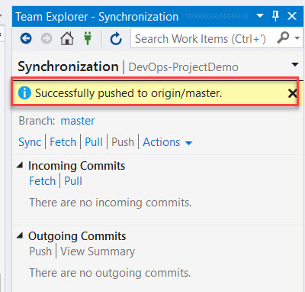

In Build it will list out

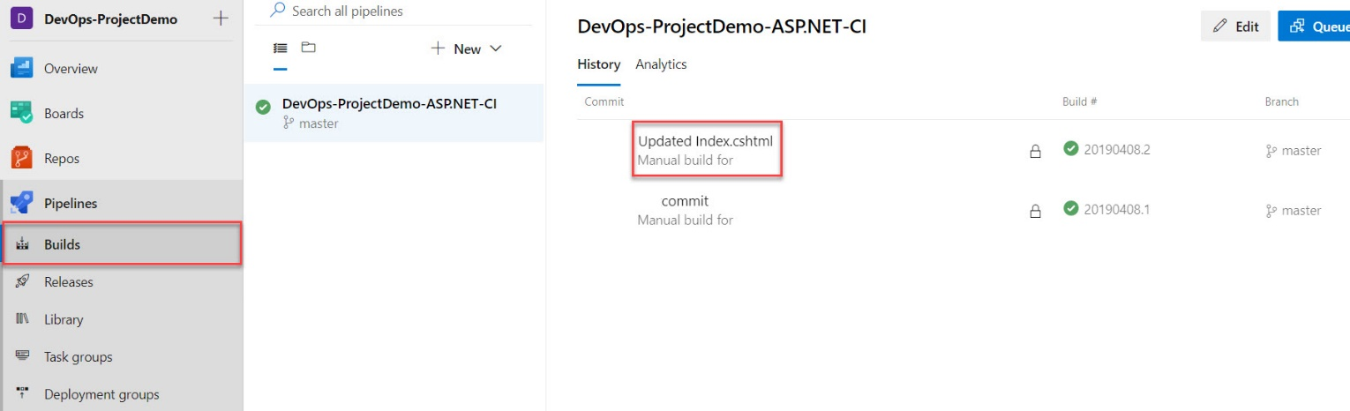

Wait for complete all jobs

**Old Version of Web**  **Updated version**

